DEPARTMENT OF COMPUTER SCIENCE & ENGINEERING
ABES ENGINEERING COLLEGE, GHAZIABAD
SOFTWARE REQUIREMENTS
SPECIFICATION (SRS)
Project Title: Early Disease Prediction System
Standard Academic Compliance: IEEE Std 830-1998
————————————————————————————
SUBMITTED BY: | Ritanshu Tiwari (Roll No: 2400321530165)  Degree: Bachelor of Technology (B.Tech)  Academic Year: 2026 - 2027  Department of Computer Science & Engineering  Status: 3rd Year Project Specification  Date of Submission: 01-10-2026

Document Revision & Approval History
Version | Date | Description / Major Changes | Prepared By | Reviewed By
0.1 | 15-Sep-2026 | Initial Draft & Scope Definition | Project Team | Project Guide
1.0 | 01-Oct-2026 | Final 3rd Year SRS Baseline | Ritanshu Tiwari | Project Guide / Committee

Guidance Note: This Software Requirements Specification document follows the IEEE 830-1998 academic structure and is customized to the implemented Early Disease Prediction System.

1. Introduction
1.1 Purpose
The purpose of this Software Requirements Specification (SRS) document is to provide a complete and clear definition of the functionality, external interfaces, performance expectations, constraints, and design requirements of the Early Disease Prediction System. The document serves as the baseline reference for development, testing, academic evaluation, deployment, and future enhancement of the project.
1.2 Scope of the System
The application addresses the need for a simple web-based machine-learning system that can provide preliminary predicted disease-risk results from health-related input parameters. The current system contains separate prediction modules for Diabetes, Heart Disease, and Liver Disease.
- In-Scope Capabilities: disease selection, health-parameter input forms, input processing, disease-specific Logistic Regression inference, prediction-result display, saved Joblib models, Flask web integration, GitHub source control, and Render cloud deployment.
- Out-of-Scope Boundaries: medical diagnosis or treatment, real-time clinical monitoring, hardware/sensor integration, commercial payment processing, and production-grade hospital/EHR integration. Kidney Disease Prediction is not part of the current system.
- Expected Benefits: quick preliminary risk estimation, a common web interface for multiple disease models, reusable machine-learning components, easier demonstration and deployment, and an architecture that can be extended with additional disease modules.
1.3 Definitions, Acronyms, and Abbreviations
Category | Term / Acronym | Definition / Standard Context
Standard | SRS | Software Requirements Specification.
Architecture | API | Application Programming Interface used for software communication.
ML | Machine Learning | Computational methods used to learn patterns from data and generate predictions.
Model | Logistic Regression | Classification algorithm used by the Diabetes, Heart Disease, and Liver Disease modules.
Storage | CSV | Comma-Separated Values files used for current dataset storage.
Deployment | Render | Cloud hosting platform used to deploy the Flask application.
Project Specific | Joblib .pkl | Serialized model file used by Flask for prediction.
1.4 References
- IEEE Std 830-1998: IEEE Recommended Practice for Software Requirements Specifications.
- Ian Sommerville, Software Engineering, Pearson Education.
- Project datasets were obtained from Kaggle. The implementation uses Python, Pandas, NumPy, scikit-learn, Matplotlib, Seaborn, Joblib, Flask, HTML5, CSS3, Jupyter Notebook, VS Code, Git/GitHub, and Render.
1.5 Document Overview
The remainder of this SRS describes the overall product perspective, users, operating environment, constraints, assumptions, functional requirements, external interfaces, non-functional requirements, and standard system-design models for the Early Disease Prediction System.
2. Overall Description
2.1 Product Perspective
The project is a web-based machine-learning system consisting of an HTML/CSS presentation layer, a Flask application layer, and three independent serialized ML model components. CSV datasets are used during model development. MySQL is planned as a future persistence layer, while the current prediction workflow does not require a relational database.
[System Context Diagram Placeholder]
User → Web Interface → Flask Application → Disease-specific ML Model → Predicted Result
Implemented modules: Diabetes | Heart Disease | Liver Disease

2.2 User Classes and Characteristics
The system is primarily intended for two user categories: an End User who enters health parameters and views a predicted result, and the Project Developer/Administrator who maintains datasets, models, Flask routes, templates, and deployment configuration.
User Role / Persona | Technical Proficiency | Core Responsibilities & Rights
End User / Visitor | Basic | Select disease module, enter health parameters, submit prediction request, and view the predicted result.
Project Developer / Administrator | Intermediate to High | Maintain datasets, train/evaluate models, update .pkl files, maintain Flask routes/templates, and manage GitHub/Render deployment.
Guest / Public Visitor | Basic | Read-only access to promotional landing pages, system overview, public catalogues, and self-registration portal.
2.3 Operating Environment
The application operates in a browser-based client environment and a Python/Flask server environment. Development is performed using Python, Jupyter Notebook and/or VS Code; deployment is performed through GitHub and Render with Gunicorn.
- Client Requirements: Modern web browsers such as Google Chrome, Mozilla Firefox, Microsoft Edge, or Safari. The interface is designed for normal desktop and mobile browser use.
- Server Runtime Environment: Linux-based Render web service with Python 3.x and Gunicorn serving the Flask application.
- Data and Model Storage: CSV files for current datasets and Joblib .pkl files for trained Diabetes, Heart Disease, and Liver Disease models. MySQL is planned for future database storage.
2.4 Design and Implementation Constraints
- Academic Budget Constraint: The project is designed to use free or low-cost development and cloud resources such as GitHub and Render.
- Medical Safety Constraint: The system must present its output as a predicted result/risk estimate and not as a medical diagnosis or treatment recommendation.
- Modularity Standard: Disease-specific models, Flask routes, templates, and data-processing components are kept modular so that additional disease modules can be added later.
2.5 Assumptions and Dependencies
- Assumptions: Users have a modern browser and internet connectivity and provide valid health-related input values in the fields required by the selected model.
- Dependencies: Availability of the Render deployment service, GitHub repository, compatible Python packages, serialized Joblib model files, and the datasets used for model development.
3. System Features and Functional Requirements
Requirements are categorized by disease-prediction and application subsystems with unique requirement identifiers (FR-x.x).
3.1 Module 1: Disease Selection and Input Capture
Req ID | Feature Description | Input / Validation Rule | Priority
FR-1.1 | Disease Module Selection | User selects Diabetes, Heart Disease, or Liver Disease. | High
FR-1.2 | Health Data Input | Disease-specific health parameters entered through the web form. | High
FR-1.3 | Input Validation | Required numeric fields must contain valid values before prediction. | High
FR-1.4 | Prediction Submission | Form is submitted to the corresponding Flask POST route. | High
3.2 Module 2: Machine Learning Prediction Engine
Req ID | Feature Description | Input / Validation Rule | Priority
FR-2.1 | Model Loading | Flask loads the correct Joblib .pkl file for the selected disease. | High
FR-2.2 | Automated Prediction | Logistic Regression model processes the supplied feature vector. | High
FR-2.3 | Prediction Result | System displays the returned predicted result on the disease page. | High
3.3 Module 3: Model Development, Evaluation, Deployment & Maintenance
Req ID | Feature Description | Input / Validation Rule | Priority
FR-3.1 | Dataset Development | CSV datasets are loaded for preprocessing and model development. | High
FR-3.2 | Model Evaluation | Model performance is evaluated using accuracy and classification evaluation. | Medium
FR-3.3 | Model Serialization | Trained models are saved as Joblib .pkl files for deployment. | High
FR-3.4 | Source Control & Deployment | Source is maintained on GitHub and deployed through Render. | High
4. External Interface Requirements
4.1 User Interfaces (UI)
The interface provides a dashboard for selecting Diabetes, Heart Disease, or Liver Disease and disease-specific forms for entering health parameters. Forms are designed to use clear labels, straightforward submission controls, and a visible prediction-result area.
[User Interface Wireframe Mockups]
1. Home / Disease Selection Dashboard
2. Diabetes Prediction Form
3. Heart Disease Prediction Form
4. Liver Disease Prediction Form
5. Prediction Result View

4.2 Hardware Interfaces
The system has no dedicated embedded-hardware interface. Standard keyboard, mouse/touch input, display, and internet connectivity are sufficient.
- Standard Deployment: Standard input/output peripherals such as keyboard, mouse/touch input, and display.
- Embedded / IoT Interfaces: Not implemented in the current project.
4.3 Software Interfaces
- Python/Flask provides the application interface between browser forms and the machine-learning models. Pandas, NumPy and scikit-learn support data processing and prediction; Joblib loads the serialized models.
- Cloud Utilities: GitHub is used for source-code repository hosting and Render is used for cloud deployment. No external enterprise API is required for the current prediction workflow.
4.4 Communication Interfaces
- Web Traffic Protocol: HTTP/HTTPS as provided by the Render deployment platform.
- Form Data: Browser-to-Flask communication uses standard HTTP GET and POST requests and HTML form parameters.
5. Non-Functional Requirements (NFRs)
Attribute | Target Metric / Standard | Verification & Testing Method
5.1 Performance | Prediction should complete within a practical web-response interval under normal academic use. | Manual browser testing and Render/application logs.
5.2 Security | Avoid unnecessary sensitive-data storage; use environment variables for future secrets. | Code review and deployment configuration inspection.
5.3 Reliability | Application should start successfully and load all configured models without file/path errors. | Deployment logs and repeated startup tests.
5.4 Portability | Support modern Chrome, Edge, Firefox, and Safari on common desktop/mobile viewports. | Cross-browser and responsive UI testing.
5.5 Maintainability | Disease modules and model files remain separated and independently replaceable. | Source-code structure review.
5.6 Usability | Clear labels, simple forms, and visible prediction results. | Manual usability testing.
6. System Design and Analysis Models
The academic design models below illustrate the static and dynamic behavior of the Early Disease Prediction System. The current ER model is presented as a proposed future persistence design because the present implementation uses CSV datasets rather than MySQL records.
Diagram Type | Objective & Scope | Deliverable Format
Use Case Diagram | Maps the user to disease selection, health-data submission, and prediction-result viewing. | UML diagram.
Data Flow Diagram (DFD) | Shows user input flowing through Flask and the disease-specific prediction model. | DFD Level 0 and Level 1.
Entity-Relationship Diagram (ERD) | Shows a proposed future MySQL structure for users, disease models, and predictions. | ERD / Crow's Foot-style diagram.
Activity / Sequence Diagram | Shows the chronological interaction from form submission to model prediction and result display. | UML activity/sequence diagram.
7. Academic Review & Sign-Off
This Software Requirements Specification document has been prepared for third-year B.Tech project review and academic evaluation under the guidance of Aaditya, Mentor.
Project Coordinator / Guide | Internal Examiner | Head of Department (HOD)
Aaditya, Mentor  Signature: __________________  Date: __________________ | Signature: __________________  Date: __________________ | Signature: __________________  Date: __________________

Project-Specific Technical Summary
Technology Stack
Technology | Purpose
Python | Primary programming language and ML implementation.
Pandas / NumPy | Data loading, cleaning, manipulation and numerical operations.
scikit-learn | Logistic Regression, preprocessing, train/test split and evaluation.
Matplotlib / Seaborn | Exploratory data analysis and visualization.
Joblib | Saving and loading trained ML models.
Flask | Backend web application and prediction routes.
HTML5 / CSS3 | Frontend interface.
Jupyter Notebook / VS Code | Model experimentation and application development.
CSV | Current dataset storage.
Git / GitHub | Version control and source-code repository.
Render / Gunicorn | Cloud deployment and WSGI serving.
MySQL | Planned future database storage.

Disease Model Summary
Disease | Algorithm | Reported Accuracy | Dataset Source
Diabetes | Logistic Regression | Approximately 77% | Kaggle
Heart Disease | Logistic Regression | 79% | Kaggle
Liver Disease | Logistic Regression | 80% | Kaggle

Project Methodology
The project follows a Scrum-based Agile methodology. Development is organized into iterative activities covering requirement analysis, dataset preparation, exploratory data analysis, preprocessing, model training, evaluation, Flask integration, interface development, testing, deployment, and documentation.

Current and Future Data Storage
The current project uses CSV files during model development and inference preparation. MySQL is planned as a future database layer for persistent user/prediction records, audit information, and scalable application data management.

Deployment Architecture
The source code is maintained in the GitHub repository ritanshucoding/HCL-PROJECT. The Flask web application is deployed through Render. Gunicorn is used as the production WSGI server. Disease-specific Joblib model files are stored inside their respective model directories and loaded by the Flask application.

Reported Model Performance
The project-reported model accuracies are: Diabetes approximately 77%, Heart Disease 79%, and Liver Disease 80%. These figures are model evaluation results supplied for this academic report and should not be interpreted as clinical diagnostic accuracy.

System Architecture Diagram
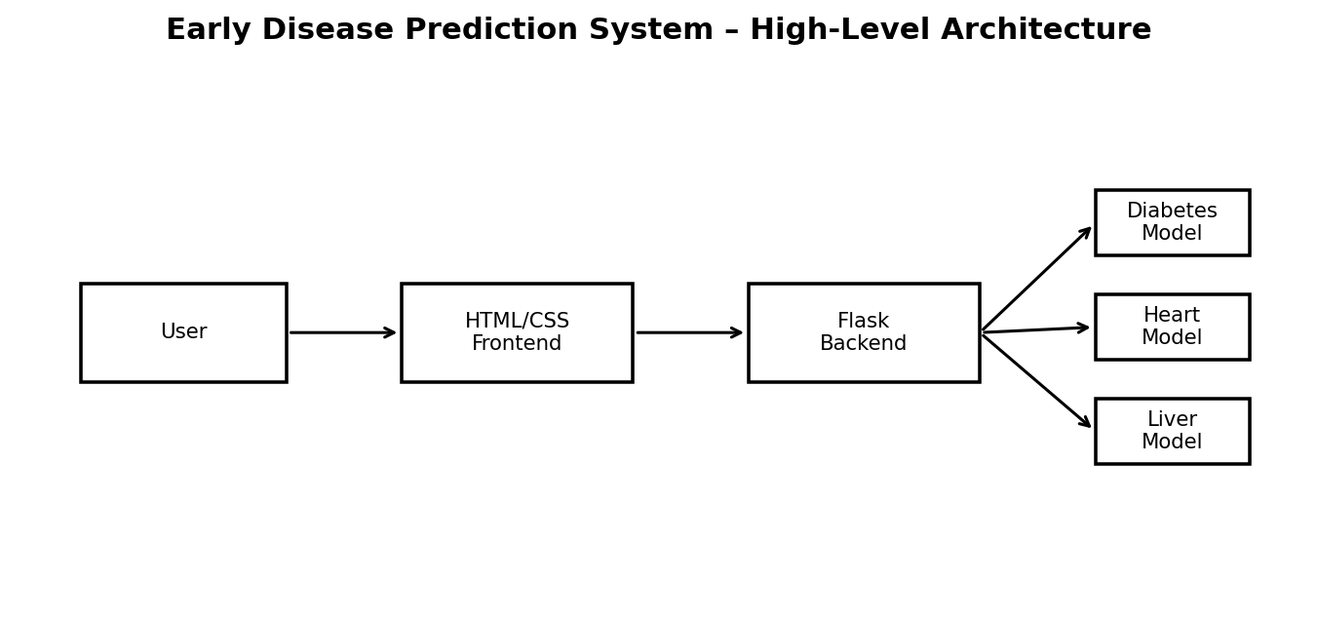

Use Case Diagram
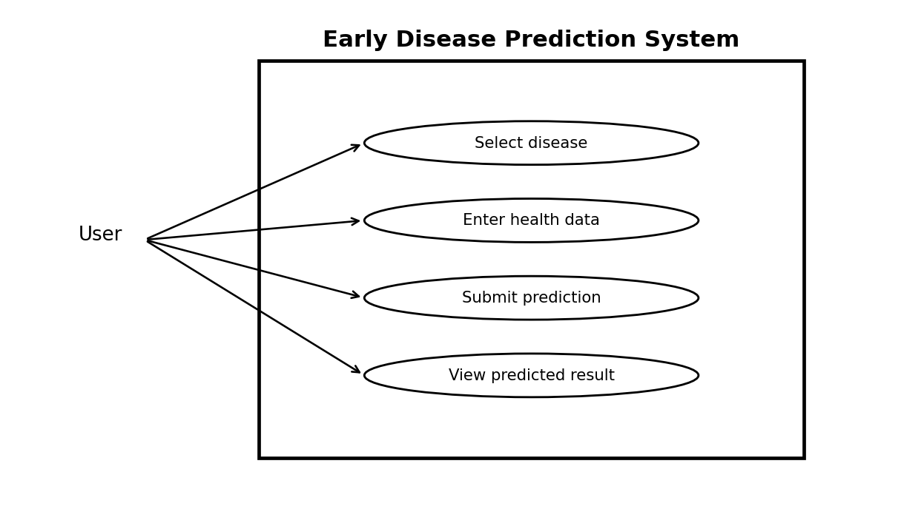

Data Flow Diagram – Level 0
